

***SOFTWARE REQUIREMENT SPECIFICATION***

**Green Strips Web App**

|  |  |
| --- | --- |
| VERSION: [1.0] | REVISION DATE: [ ] |

|  |  |  |  |
| --- | --- | --- | --- |
| **Approver Name** | **Title** | **Signature** | **Date** |
|  |  |  |  |
|  |  |  |  |
|  |  |  |  |
|  |  |  |  |

**Contents**

[GREEN STRIPS] 1

1. [Product](#OLE_LINK1) Description 3

1.1 Purpose 3

1.2 Scope 3

1.3 Stakeholders and Users 3

1.4 Assumptions 4

1.5 Constraints 4

2. Functional Requirements 5

3. [Non](#_Hlk478474100) Functional Requirements 6

3.1 Performance Requirements 6

3.2 Safety Requirements 6

3.3 Security Requirements 6

4. External [Interface](#_Hlk478474133) Requirements 7

4.1 User Interfaces 7

4.2 Hardware Interfaces 7

4.3 Software Interfaces 7

4.4 Communication Interfaces 7

5. Entity Relationship Diagram………….….……………………… 8

6. [Use](#_Hlk478474221) Case Model 9

6.1 Use Case Diagram 9

7. Glossary 10

8. [References](#_Hlk478563913) 10

**1.** **Product Description**

**1.1 Purpose**

The purpose of this document is to build a web app ‘Green Strips’ which shall be a browser based system designed to buy paper bags from and advertise various products on those paper bags. The product is aimed at serving a social cause, i.e. reduce the use of plastic bags by shopkeepers and ultimately reduce the amount of plastic waste generated. This web app shall be designed to support activities like placing orders for a certain number and type of paper bags, advertising the sponsors’ products on these paper bags, log in and/or sign in of existing and/or new users respectively. Currently most of the above mentioned tasks are done in a manual manner where the buyers and advertisers contact the Green Strips administration directly and records are maintained in hardcopy form. This product shall remove the need for maintenance of all such records and transition into a smooth online procedure. The product shall also increase the visibility of the ‘Green Strips’ project and help people switch over to paper bags, thus serving the ultimate goal of reducing plastic waste.

**1.2 Scope**

The scope of this project is to provide companies with an opportunity to advertise their products and enhance their brand visibility. This in turn will provide Green Strips with the required funds to make paper bags, ready to be sold to shopkeepers which will in turn reduce the generation of plastic waste.

**1.3 Stakeholders and users**

1. **System Owner**: Green Strips Administration
2. **System Users:** 
   1. Administrators: The administrators will decide the privileges of the other users and also track the activities performed by them.
   2. Buyers: This category of users will be the ones who intend to buy the products (paper bags).
   3. Advertisers: This category of users will be the ones who intend to advertise their products on the paper bags.

**1.4 Assumptions**

* The end user should have a basic knowledge of English and computer usage.

**1.5 Constraints**

* Users should have basic knowledge of computer.
* Only English is used in GUI.
* Internet Connection is needed.

**2*.*** **Functional Requirements**

2.1. The system shall require the buyers and advertisers to log in with their respective login credentials to perform their intended tasks.

2.2. **Register the advertiser**

2.2.1. The advertiser selects the type and number of bags on which he/she wishes to advertise the respective products

2.2.2. System shall check if the advertiser already exists.

2.2.3. If not, the system shall provide the user with options to register with desired credentials.

2.2.4. The system shall then require the advertiser to fill up a form with details like organization name, email, sector, website, address, locality, etc.

2.3. **Register the buyer**

2.2.1. The buyer selects the type and number of bags on which he/she wishes to buy.

2.2.2. System shall check if the buyer already exists.

2.2.3. If not, the system shall provide the user with options to register with desired credentials.

2.2.4. The system shall then require the buyer to fill up a form with details like name, email, contact details, etc.

2.4. **Manage database**

2.4. 1. The system shall record the advertiser details and corresponding requirements in an advertiser database.

2.4.2. The system shall record the buyer details and corresponding requirements in a buyer database.

2.4.3. All new users along with their respective credentials shall be stored in a user database

**3.****Non-Functional Requirements**

**3.1 Performance Requirements**

* The software is expected to have reasonably short response time.
* It should be able to log-in and feed the records related to buyers, advertisers and give us accurate details.

**3.2 Safety Requirements**

* The system should be capable of gracefully recovering from earlier crashes and continuing the blood bank process.

**3.3 Security Requirements**

* The system shall ensure that all users register with unique credentials so that they can do their own work without intervening into another user’s work.
* Serial attacks will be avoided by maintaining a minimum time gap between successive invalid log-in attempts.

**4.** **External Interface Requirements**

**4.1 User Interfaces**

* Front- end software: HTML, CSS, Javascript
* Back-end software: Flask

**4.2 Hardware Interfaces**

* Windows
* A browser which supports HTML & Javascript.

**4.3 Software Interfaces**

|  |  |
| --- | --- |
| Software Used | Description |
| Operating System | We have chosen Windows operating system for its best support and user – friendliness. |
| Database | To save the advertiser and buyer details we have chosen MongoDB database. |
| HTML, CSS, Javascript | To implement the project UI we have selected HTML, CSS and Javascript for their interactive support. |

**4.4 Communication Interfaces**

The project supports all types of web browsers. We are using simple electronic forms for the advertiser and buyer forms.

**5. Entity Relationship Diagram**

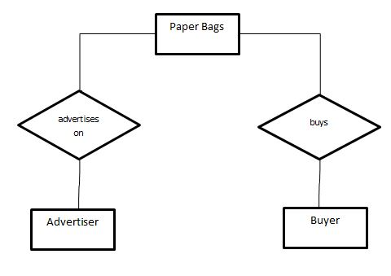

**6.****Use Case Model**

**6.1 Use Case Diagram**

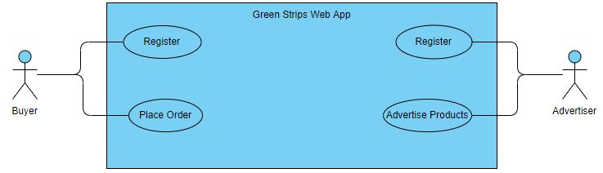

**7.** **Glossary**

|  |  |
| --- | --- |
| **Term** | **Definition** |
| Administrator | the administration department of Green Strips. |
| Advertiser database | is a table that stores all advertiser related details |
| Buyer database | is a table that stores all buyer related details. |
| Crash | a computer crash means that the computer itself stops working or that a program aborts unexpectedly. |
| Software Requirement Specification | a document that completely describes all of the functions of a proposed system and the constraints under which it must operate. For example, this document. |
| Stakeholder | any person with an interest in the project who is not a developer. |
| User database | is a table that stores all login credentials of users. |

**8.** **References**

<https://krazytech.com/projects>